Group Presentation
Radioactivity

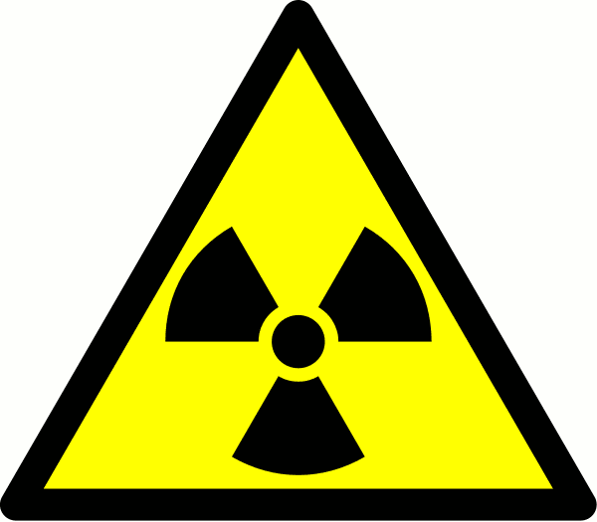

Radiation surrounds us naturally from the sun to some types of rocks.
Our body cells are designed to repair some radiation damage. However, nuclear radiation can damage or destroy living cells, stop vital organs in the body working properly, and cause cancer.

The stronger the radiation, and the longer the exposure time, the greater the risk.

Your Task:

- Choose 1 use of nuclear technology (some ideas listed below), discuss facts and information about them as a group.
- This should be 5-6 Slides
- Introduce the topic – focus on importance to society.
- Discuss ADVANTAGES and DISADVANTAGES of these technologies.
- Summarise your ideas about your chosen topic as a concise document.
- Include a detailed and varied Bibliography.

Your presentation will be 4 min per group (max. 4 /group).
Some possible topics include:
- Nuclear medicine (e.g. cancer treatment, medical imaging)
- Nuclear power generation
- Radiocarbon dating
- Food irradiation
- Industrial uses (e.g. detecting leaks or testing materials)

Slide by Slide Guide

Slide 1: Introduction

What is your groups chosen technology?

Why is it important or interesting?

Slide 2: How It Works

Explain the science behind it (in simple terms).

Include diagrams or visuals to help your audience understand.

Slide 3: Advantages

How does this technology benefit people or the environment?

What problems does it help to solve?

Slide 4: Disadvantages / Risks

What are the dangers or ethical concerns?

How can these risks be managed?

Slide 5: Summary & Reflection

What is your group’s overall opinion — is it worth the risk?

What did you learn from your research?

Slide 6 (Mandatory) Bibliography

List all your sources (at least 3–5, using consistent formatting).
- Science as a Human Endeavour (under Australian Curriculum)
- Excellent Achievement
- High Achievement
- Sound Achievement
- Approaching Year Achievement

